

Year 2 Lea Valley Learning Journey

 | Autumn 1 | Autumn 2 | Spring 1 | Spring 2 | Summer 1 | Summer 2
Reading | 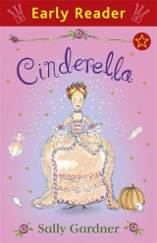  Cinderella  Sally Gardner | 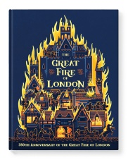  The great fire of London  Emma Adams | 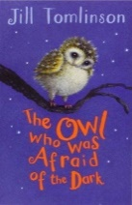  The owl who was afraid of the dark  Jill Tomlinson | 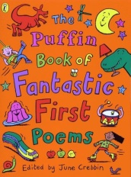  The puffin first book of fantastic first poems  June Crebbin | 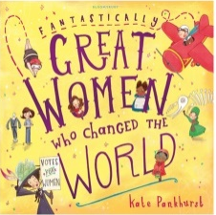  Fantasically great women who changed the world  Kate Pankhurst | 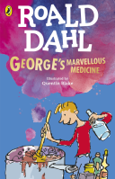  George’s Marvellous Medicine  Roald Dahl
Writing | Writing to recount: Cinderella’s diary  Writing to describe:  Character description  Writing to inform:  Judaism leaflet  Writing to entertain:  The story of Cinderella | Writing to recount:  The great fire of London  Writing to describe:  Setting description  Writing to perform  Winter poems | Writing to explain:  Non-chronological report  Writing to recount:  Letters about the dark | Writing to instruct:  How to look after a plant  Writing to recount:  Gruffalo trip  Writing to perform:  What is pink? | Writing to entertain: Song of the sea  Writing to inform:  Biography | Writing to recount: Newspaper  Writing to persuade:  Going to beach  Writing to inform:  Fact file on themselves
Maths | Place Value: represent, proportion, compare and order numbers to 100  Addition and Subtraction: add and subtract across 10, adding 2 digit numbers  Shape: recognise and sort 3D and 2D shapes, symmetry |  | Money: Count pounds and pence, make a pound and find change  Multiplication and division: adding equal groups, 2, 5 and 10 times table, doubling  Length and height: measure in cm and m, compare and order lengths and heights  Mass, capacity and temperature: measure in g and kg, l and ml, temperature |  | Fractions: recognise and find half, quarter, three-quarters and thirds  Time: tell the time to 5 minutes including half past, quarter past and quarter to, minutes in an hour, hours in a day  Statistics: tally charts, pictograms  Position and direction: describe movement and turns
Science | Living things and their habitats  What makes a good habitat? | Use of everyday materials  Can any material do any job? | Living things and their habitats  What makes a good  habitat? | Animals including Humans  How does a baby grow into a healthy adult? | Animals including Humans  How does a baby animal grow into a healthy animal adult? | Plants  Can I grow a plant?
Art | Explore and Draw  Introducing the idea that artists can be collectors and explorers as they develop their drawing and composition skills |  | Expressive Painting  Explore colour mixing and experimental mark making to create abstract still life |  | Stick transformation project  Explore how to transform a familiar object into new and fun forms
Computing | We are astronauts:  How can I programme a robot? | We are games testers:  How do computer games work? | We are photographers  How do I take and edit a good photo? | We are researchers  How can I research a topic safely online? | We are animators  How do I make a stop-motion animation? | We are zoologists  How do I collect, sort and present data?
DT | Textiles  Making pouches |  | Mechanisms  Making a moving monster |  | Cooking and nutrients  Exploring a balanced diet – designing and making a wrap
Geography | Our Wonderful world  Where would you like to travel to? |  | A study of  What are the many features of … |  | Holidays and camping  Where could I go on holiday?
History | Mary Seacole and Florence Nightingale  Why are these women significant figures in our history? |  | The great fire of London  What effect did the great fire have on the city of London? |  | The Stone Age  What was life like in the Stone Age? | The Neolithic Age  How do we know how people lived in the past?
Music | Hands, Feet, Heart  South African styles | Playing in an orchestra  Classical music | I wanna play in a band  Rock | Zootime  Reggae | Friendship song  Improvising and composing | Reflect, Rewind and Replay  Western Classical Music
PE | Funamentals  Balancing, changing direction, jumping, hopping, skipping | Ball Skills  Hitting a target in different ways | Gymnastics  Basic gymnastics on floor and aparatus | Sending and receiving  Stopping a ball travelling in different ways | Dance  Explore space and move their bodies to express an idea, mood, character or feeling | Athletics  Developing throwing, running and jumping
PSHE | Being me in my world  Rewards and consequences, recognising feelings | Celebrating Difference  Making new friends, understanding bullying and how to deal with it | Dreams and Goals  Perseverance and co-operating with others | Healthy Me  Healthy choices and relaxation | Relationships  Different types of family, physical contact boundaries | Changing Me  Growing from young to old and differences between boys and girls
RE | An introduction to Judaism  What do Jews believe? | Life as a Jew  What is important in Judaism? | An introduction to Islam  What do Muslims believe? | Life as a Muslim  What is important in Islam? | An introduction to Buddhism  What do Buddhists believe? | Life as a Buddhist  What is important in Buddhism?
Spanish | All about me  Que tal? Como Estas? (How are you?)  Answering with adjectives  Book: El monsturo de colores |  | Birthdays  Birthdays  Spanish Passports |  | My classroom  Classroom objects  Shapes and adjectives  Positions
Trips | Synagogue | The Tower of London | Natural History Museum at Tring | Tottenham Marshes | Stone Age Survival Day in Epping Forest | Beach

